The Star Inn
Christmas Menu

Parsnip Soup served with crusty bread
Chicken Liver Pâté, brown toast & red onion chutney
Breaded Brie Wedges served with cranberry chutney and salad
Prawn Cocktail
Crispy Chilli Beef Salad
Cured Salmon served with rocket, baby capers and toasted pine nuts
*********
Traditional Roast Turkey served with all the trimmings
Roast Sirloin of Beef served with all the trimmings
Slow-Cooked Lamb Shank served with onion mash and vegetables
Vegan Nut Roast served with vegetables and roast potatoes
Pan-Fried Salmon served with crushed new potatoes, green beans and hollandaise sauce
Wild Mushroom, Spinach and Chestnut Risotto
Slow-Roasted Pork Belly with bubble and squeak, honey-roasted carrots, black pudding and sage butter
**********
Traditional Christmas Pudding with brandy sauce
Sticky Toffee Pudding
Chocolate and Cranberry Brownie
Apple and Pear Crumble
Salted Caramel Cheesecake
A Selection of English Cheese served with quince jelly and biscuits (£2.50 supplement)
Selection of Ice Creams and Sorbets
**********
Choice of Tea or Coffee served with Chocolate Mints
3 Courses: £25.95 per person
2 Courses: £19.95 per person

For reservations please call 01293 871264. A deposit of £5 per person required at time of booking.
Pre-order menu choices must be received 5 days prior to your reservation.
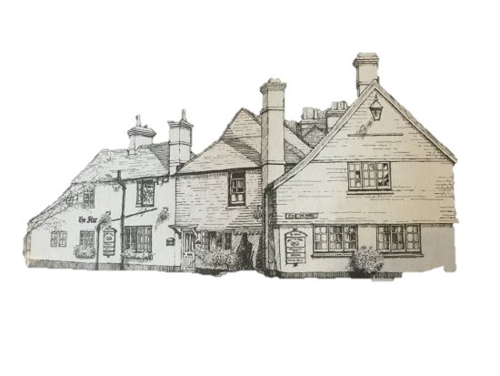
Gluten-free dishes available upon request and please inform staff of any food allergies.
Christmas menu available 1st – 24th December, excluding Sundays.

