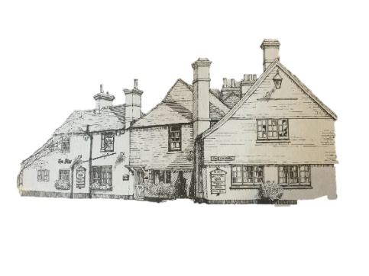
The Star Inn
Christmas Menu
Parsnip Soup with crusty bread
Chicken Liver Pâté, brown toast & red onion chutney
Breaded Brie Wedges served with chutney and salad
Crispy Chilli Beef Salad
Deep Fried Whitebait
Prawn Cocktail
******
Traditional Roast Turkey, served with all the trimmings
Slow-cooked Lamb Shank Kleftico served with mash and vegetables
Roast Sirloin of Beef served with all the trimmings
Mediterranean vegetable lasagne with chips and salad
Nut Roast served with all the trimmings
Pan-Fried Salmon served with crushed New Potatoes, Vegetables and Hollandaise Sauce
Slow-roasted Pork Belly with bubble and squeak, honey-roasted carrots and a cider jus.
******
Traditional Christmas Pudding with Brandy Sauce
Sticky Toffee Pudding
Chocolate and Cranberry Brownie
Apple and Plum Crumble
Lemon & Ginger Cheesecake
A selection of Ice Creams and Sorbets
A Selection of English Cheese, served with Biscuits and chutney (£2.50 supplement)
******
Choice of Tea or Coffee with Chocolate Mints

3 Courses - £26.95
2 Courses - £21.95
For reservations, please call 01293 871264. A £5 deposit per person will be required at time of booking.
Pre-order menu choices must be received 5 days prior to reservation.
Gluten-free dishes available upon request and please inform staff of any allergies.
Available 1st December – 24th December (Excluding Sundays)

